Budget Rent-a-Car
of British Columbia

Rate Control Tutorial

Version 1.00

Note: The information contained in this document is confidential and may not be disclosed to any parties outside of Budget Rent-a-Car of British Columbia Ltd. without written consent by one of its officers.

Copyright (C) 2009 Budget Rent-a-Car of British Columbia Ltd.
Table of Contents

1 Introduction to Rates 1
2 Setting up a Base/Rack Rate 2
Defining a Rate 2
Specifying Rate Levels and Amounts 3
Assigning Pick Up and Drop Off Locations 6
Defining Drop Off Charges by Location 7
Assigning Rates for Reservation and Walk Up 9
3 Setting up a Package Rate 14
Defining a Rate 14
Specifying Rate Levels and Amounts 14
Adding Restrictions to the Rate 15
Assigning Pick Up and Drop Off Locations 15
4 Setting up a Truck Rate 17
Defining a Rate 17
Defining a Rate 17
Specifying Rate Levels and Amounts 17
Assigning Pick Up and Drop Off Locations 19
Defining a Rate 20
Specifying Rate Levels and Amounts 20
Assigning Pick Up and Drop Off Locations 21
5 Setting up a Tour Rate 23
Defining a Rate 23
Specifying Rate Levels and Amounts 24
6 Setting up an Organization 26
Associating a Rate with an Organization 26

1 Introduction to Rates

Rates can be classified into three segments: Local, BCD, and Maestro rates. Local rates are those rates that are defined and stored locally by Budget. BCD rates are the rates assigned to organizations at the Budget Corporate level. The corporate will send monthly BCD rates to Budget Rent-a-Car of B.C. Ltd. who in turn will upload them to GIS. There is no facility in GIS to enter, store or retrieve Maestro rates beyond what is provided for local and BCD rates. GIS also allows you to control walk up, same day and future day reservations rates. Rates are set up and controlled through the Vehicle Rate Maintenance and Location Maintenance screens. In this tutorial, we will talk about how you can set up base rates for your daily car rentals in GIS, how you can create a special package rate for a long weekend, how to set up rates for truck rentals and how to add a tour rate into GIS. We will also guide you through the process of BCD rate creation.

2 Setting up a Base/Rack Rate

Defining a Rate

A rack rate is the default rate which will be applied to the reservation or contract after the CSR enters the pick up and drop off locations/dates and vehicle class. Let’s create a base rate for our daily vehicle rentals. This rate will only be available for all vehicle classes at the airport and downtown locations.

Access the Vehicle Rate Maintenance screen by selecting it from the Rate Control menu. Start defining your rate by entering a Rate Name. The Purpose field is a descriptive field that is used to identify the business purpose of the rate. The Valid From and To Dates control when the rate may be used for rentals. Select a Purpose for the rate from the drop down menu. We will name our rate Daily95, effective from Jan 10, 2005 and select ‘Standard’ as its purpose.

Now, we need to specify the nature of the rate by turning on the flags that apply. Our Daily95 rate is a regular rate which will honor all membership discounts and frequent flyer points. Vehicle upgrades, referral fees and commission are also applicable to this rate. So go ahead and check the flags that apply to our rate.

Incentive Upsell | Specifies whether an up sell should be encouraged when using this rate.
Flex Discount Allowed | Specifies whether reservation agents or customer service agents may apply a flex discount to a reservation or contract when using this rate.
Membership Discounts Allowed | Specifies whether membership discounts, such as BCAA, will be honored when using this rate.
Frequent Flyer Plans Honored | Specifies whether frequent flyer plans will be honored when using this rate.
Commission Paid | Specifies whether or not commissions are paid when using this rate.
Referral Fee Paid | Specifies whether or not referral fees are paid when using this rate.
Insurance Transfer Allowed | Specifies whether insurance transfers are allowed when using this rate.
Km Drop Off Charge | Specifies whether regular, automatically calculated drop charges will be applied to this rate or whether manually calculated drop charges will apply (used for provincial government).
Warranty Repair Allowed | Specifies whether this rate is used for warranty repairs, if so, enter the manufacturer name. Do not select this flag as it is no longer used in GIS.
Calendar Day Rate | Specifies whether or not the rental is calculated by day using this rate (used for customers who have rental vehicle coverage).

Any comments you enter in the left section will be printed on the contract whereas those in the right column will only appear on the GIS screen for reference. Enter a description for Daily95 in the right column and save your data. Take a look at Figure 1 to check our progress so far.

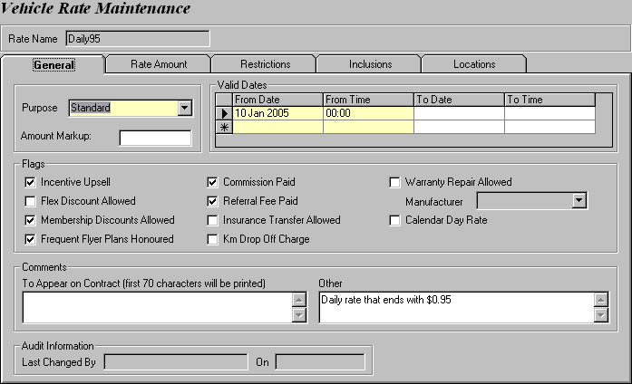
Figure 1: Entering basic information for Daily95.

Specifying Rate Levels and Amounts

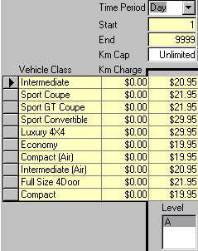
Let’s move to the Rate Amount tab to define the rate in details. Notice that the only field available to you is the New Level button at the bottom of the screen. Click it and the screen will be enabled. Each rate may have multiple levels, which are sequentially named A to Z. One way to utilize the Level field is by setting different dollar amounts for different rate levels. In our example, we will implement two levels with the second level being a dollar higher than the first.

Next, define the Time Period. Keep in mind that each time period (except for Flat, AM, PM, OV) has to start with 1 and end with 9999. So select ‘Day’ from the Time Period drop down and enter 1 and 9999 in Start and End. In the Km Cap field, type ‘Unlimited’ to offer unlimited mileage to the customers. The last step is to determine the dollar amount to charge for each vehicle class per time period. In the Vehicle Class grid, click on the first yellow row and an arrow will appear to the right. Click on the arrow to choose a vehicle class and enter its daily rate for each of your
Figure 2: Daily rate for Daily95.
vehicle classes, as shown in Figure 2.

You may wonder whether you can set up a time period of Hour on top of the time period of Day that you have already set up. The answer is yes but it is somewhat tricky when you set up the starting hour for your rate.

NOTE
The Start and End periods cannot overlap and must be continuous between the time periods. For example, for two time periods of Day, start and end values of 1 to 6 and 7 to 10 is allowable, but 1 to 6 and 8 to 10 is not allowed because there is a gap between the start and end sets. Also not allowed would be 1 to 6 and 3 to 10 because there is an overlap between the start and end sets.

NOTE
The order of the time periods is trivial. In other words, you can list Hour after Day or Month to Day then to Week as long as your start and end periods are valid.

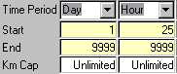
Recall that you defined your time period of Day to start at 1. If you define your time period of Hour to start at 1, then it would be a redundant action since the first to twenty-fourth hour are all included in the first day. Therefore, if you have time periods for both Day and Hour, let the Day start at 1 and the Hour at 25. So now our time period grid will look like Figure 3. Figure 3: Time period for Hour.

To determine the rate amount for the time period of Hour, follow the formula set in Wizard, which is Hourly Rate ($) = Daily Rate/2 + 0.01 for all vehicle classes.

NOTE
As of this writing, GIS does not allow rates to be assigned on specific days. If you want your rate to be valid on Mondays to Thursdays only, you have to do it the rough way – by controlling the actual dates through the Valid Dates grid in Vehicle Rate Maintenance (See Figure 4).

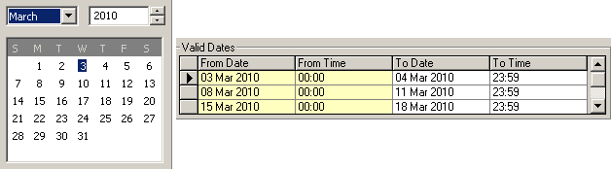
Figure 4: Setting up the rate for Mondays to Thursdays for the month of March using their actual dates.

Once you are finished, click New Level and the next sequential level, Level B, in our case will be added. Notice that all applicable vehicle classes, time periods and km charges in Level A appear in B and all you have to do is enter the dollar amounts. Recall that we want our dollar amounts to vary by rate level. So go ahead and increment the daily rate for each vehicle class by a dollar. Use the Wizard formula again to calculate the new Level B hourly rates. When everything is done, you have two levels for Daily95, as shown in Figure 5. Do not forget to save your work!

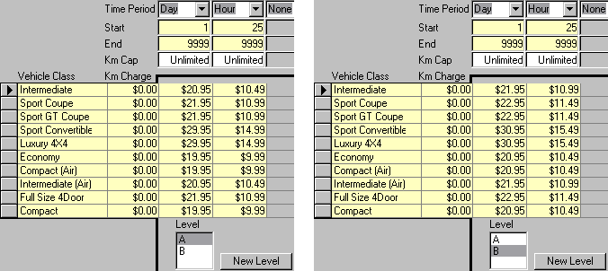
Figure 5: (Left) Rate amounts for Level A; (Right) Rate amounts for Level B.

NOTE
Rate levels are tied to their rate. If a rate is invalid, then all its rate levels will no longer be valid as well.

NOTE
You do not necessarily have to increment each level by a dollar. You should, however, make the distinction between each level clear and consistent to avoid any confusion among your staff.

For example, level B can be a dollar more than level A, but level C should not be two dollars more than level B and level D three dollars more than level C.

Now that you have defined the rate amounts for all your vehicle classes, the next question is how does GIS calculate the rental amount? It’s actually quite simple. GIS first takes the length of rental (date and time of check in – date and time of check out), and uses it to search for all possible time period combinations of the rate attached to the contract. Lastly it chooses the cheapest combination and applies the rental rate to the contract.

Assume that a customer, whose contract is assigned the rate Daily95, checks in an Economy car after one day and one hour. In Figure 5, the daily rate for an Economy is $19.95 whereas the hourly rate is $9.99. GIS will then gather all the possible time period combinations, which are:

Combo 1: Two days - $19.95 * 2 = $39.90
Combo 2: One day & one hour - $19.95 + $9.99 = $29.94 (cheapest!)

After analyzing the rates for all possible combinations, GIS uses the second combination’s rate to calculate the vehicle rental.

Let’s look at another example. Assume that the same customer checks in the Economy car after one day and two hours this time. The possible time period combinations GIS will analyze are as below:

Combo 1: Two days - $19.95 * 2 = $39.90 (cheapest!)
Combo 2: One day & two hours - $19.95 + $9.99 * 2 = $39.93

GIS uses the first combination’s rate to calculate the vehicle rental this time simply because it is the cheaper of the two.

We encourage you to play around with the time period and amount to find the best combination possible for your rates, especially for your special rate packages, which we will cover later in the next chapter, to protect your profit. We will skip the Restrictions and Inclusions tabs for now because Daily95 is a base rate which is generally used daily with no restrictions or inclusions.

Assigning Pick Up and Drop Off Locations

We have now arrived at the last part of the Vehicle Rate Maintenance screen – the Locations tab. This tab is mainly used to identify the pick up and drop off locations for which the rate is available. It also allows you to assign various charges for those selected pick up locations.

The top section of the screen allows the user to select one or more pick up locations into a group for which properties will be defined. Recall that our Daily95 is offered at airport and downtown only so we have to create a group for them. Start by clicking New Group. Now that the screen is no longer grayed out, select the YVR Airport and Downtown locations. Use the arrow button to move them from the Available Locations column to the Selected Pick Up Locations in Group column (See Figure 6).

NOTE
Multiple pick up location groups may be defined for each rate.

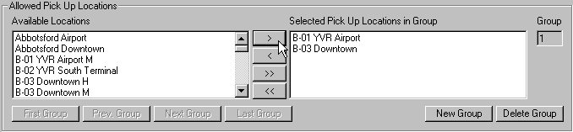
Figure 6: Selecting the pickup locations.

The next section allows for the selection of authorized drop off locations. If the Allow All Authorized Drop Off Locations check box is not selected, each allowable drop off location and whether the drop off location charge is included in the rate must be specified. Any authorized drop off locations selected will be available for all the pick up locations in the group displayed at the top of the screen. Note that the pick up location is not a valid drop off location for itself unless it is identified as an authorized drop off location.
At this point, you may wonder where you authorize your drop off locations. We will cover this topic more in the Defining Drop Off Charges by Location section.

If the Allow All Authorized Drop Off Locations check box is selected, the rate will be valid for all authorized drop off locations identified in the Location Maintenance screen for the specified pick up location. A drop off charge will be charged for all the authorized drop off locations and will not be included in the rate.

Usually, we check the Allow All Authorized Drop Off Locations box for base rates such as our Daily95. However, since our Daily95 is only offered in airport and downtown locations, select both the YVR Airport and Downtown locations in the Drop Off Location grid, as shown in Figure 7. The Include in Rate field specifies whether or not a drop off charge for each selected drop off location is included in the rate amount. Select No for both locations so that drop off charges apply where applicable.

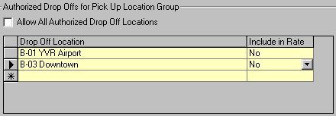
Figure 7: Selecting Airport and Downtown as the drop off locations.

The last section allows for the Km Cap, Km Charge, Flat surcharge, and Daily Surcharge to be set for the pick up location group displayed at the top of the screen. If the Km Cap and Km Charge fields are left blank, then the values used for calculation will default to the values entered in the Rate Amount tab. Leave the fields as is and save all your changes.

Defining Drop Off Charges by Location

You can apply a drop off charge to a rental if your vehicle is picked up at one location and dropped off at another. Drop off charges are defined in the Drop Off Location tab of Location Maintenance. You can access this screen by clicking on the Rate Control menu and selecting Location Maintenance. Enter a pick up location in the Location field and hit Retrieve.

You should enter all your rental and foreign locations in this grid. Start with your first location. If you authorize it as a drop off location, select Yes in the Authorized column and vice versa. Specify the associated drop off charges in both the Authorized Charge and Unauthorized Charge columns. Lastly, enter Valid From and Valid To dates. Do this for all pick up locations you specified in Figure 6 (See Figure 8 and 9).

The Default Unauthorized Charge field must also be entered. This will be used for all drop off locations that are not individually selected.

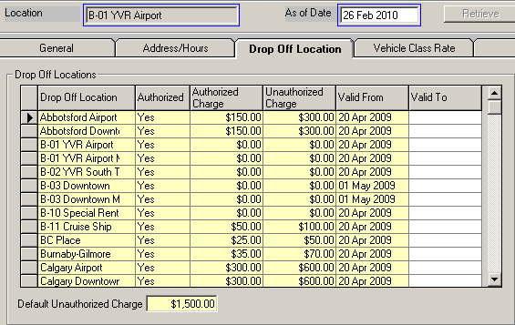
Figure 8: Authorized drop off locations and charges for YVR Airport.

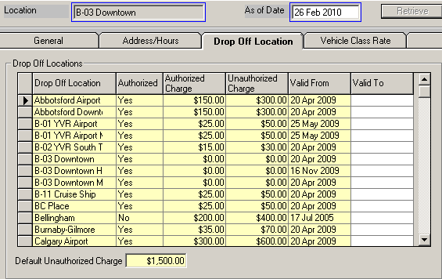

Figure 9: Authorized drop off locations and charges for Downtown.

NOTE
Specifying drop off locations in Location Maintenance and in Vehicle Rate Maintenance are very different!

In Location Maintenance, all you do is specify what the authorized and unauthorized charges are for each location if a vehicle is dropped off there.

For example, a customer who will pick up and drop off his vehicle in the Downtown location is offered our Daily95. A problem arises and the customer drops off the vehicle at the YVR Airport location. This customer will have to pay an additional drop charge amount (i.e. $25 according to Figure 8 because YVR Airport is an authorized drop off location in Figure 7). If the customer drops off the vehicle at Abbotsford Airport, he will have to pay a drop off charge of $300 (See Figure 8) on top of the rental charges based on Daily95 because this location is not authorized in Figure 7.

You can only offer a rate to a customer upon reservation or contract open if s/he picks up and drops off the vehicle listed in Vehicle Rate Maintenance’s drop off location (See Figure 6 and 7).

For example, if a customer wants to pick up a vehicle at the Downtown location, keeps it for two days and eventually drops it off at Abbotsford Airport, you will not and cannot offer him Daily95 on GIS when you make a reservation/open a contract because the drop off location is not an authorized drop off location in Vehicle Rate Maintenance for Daily95 (See Figure 7).

Assigning Rates for Reservation and Walk Up

GIS allows you to assign different rates and rate levels for walk up rentals and reservations at the specified location by vehicle classes. For each vehicle class available at the specified location, several rates (and levels) may be assigned. Each rate/level is also assigned a selection type (See Figure 10) which identifies the nature of the rate.

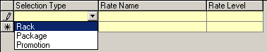
Figure 10: Three selection types for rate.

At the start of the tutorial, we specified that Daily95 applies to all vehicle classes (Refer back to Figure 2). Now that the rate is set up, we need to attach it to all vehicle classes. We will use a Full Size 4Door in our example.

Open up the Location Maintenance screen and enter ‘B-01 YVR Airport’ in the Location field then hit Retrieve. With all the airport information loaded, go to the Vehicle Class Rate tab and select the All (Date set) sub tab (See Figure 11).

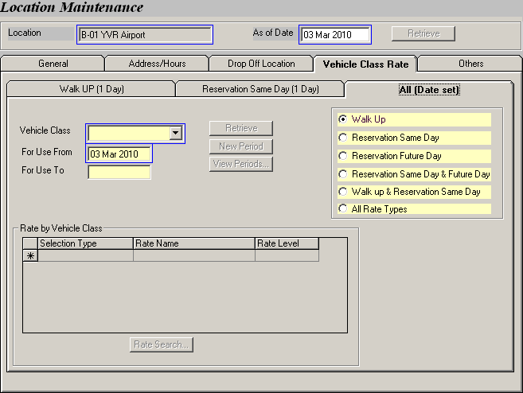
Figure 11: Setting up rates for different scenarios in the All (Date set) tab.
NOTE
We omit the Walk UP (1 Day) and Reservation Same Day (1 Day) tabs because their functionalities are duplicated in the All (Date set) tab.

On the right hand corner of the screen, select the Reservation Same Day scenario to customize the rate offered in the Reservations screen. The For Use From field defaults to the current date. Select a Vehicle Class (i.e. Full Size 4Door) and click Retrieve. Assuming that no rates have been set for your selected vehicle class on the For Use From date, GIS will pop up a warning message (See Figure 12), indicating that it cannot find any rates for your selected vehicle class. This is fine. Click OK to close the warning message and the Rate by Vehicle Class grid will be enabled.

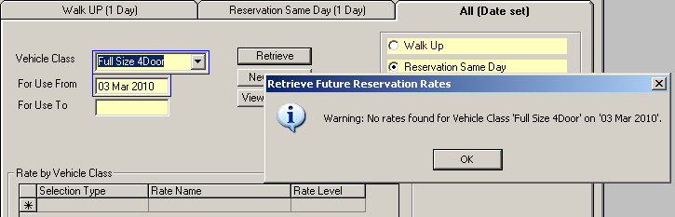
Figure 12: A warning message appears when first setting rates for a vehicle class.

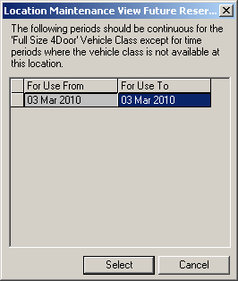
Enter the current date in the For Use To date field. Now, select ‘Rack’ from the Selection Type drop down and enter the Rate Name and Rate Level using Daily95 and A respectively. Save your changes. You can always check the valid time periods you have assigned to your vehicle class by clicking the View Periods button, as shown in Figure 13.

In GIS, rates are normally assigned in Location Maintenance on a daily basis. However, if you prefer to set rates for a specific time period, you may do so by clicking the New Period button after specifying the vehicle class and dates of usage.

Figure 13: This window records all dates where the vehicle class is assigned a rate.

NOTE
If rates are entered for a vehicle class then one and only one of the selection types must be ‘Rack’. There is no restriction for ‘Package’ and ‘Promotion’.

In the Reservations screen, Daily95 is retrieved immediately after specifying the rental information and clicking Get Data (See Figure 14). This will assign the rack rate (We previously assigned it as Daily95) to the reservation.

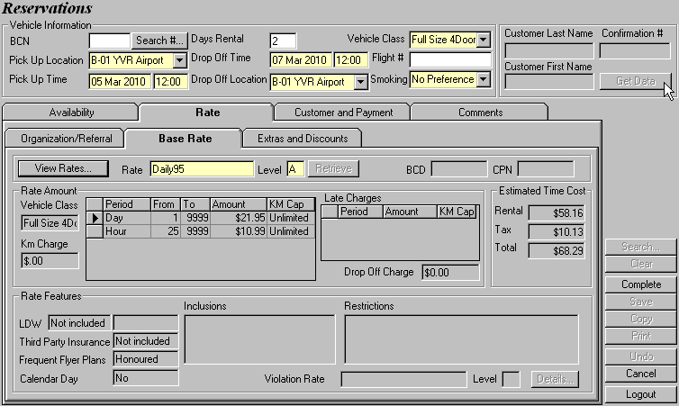
Figure 14: Click Get Data to automatically retrieve the rack rate in the Reservations screen.

We also want Daily95 to be automatically offered to a walk up if the walk up meets all requirements of Daily95 and if the customer picks a Minivan at the airport location.

This is a matter of scenario. The procedures are exactly the same as setting up a rate for reservation. Open up the Location Maintenance screen and enter ‘B-01 YVR Airport’ in the Location field then hit Retrieve. With all the airport information loaded, go to the Vehicle Class Rate tab and select the All (Date Set) sub tab.

Select the Walk Up option since we are customizing the walk up rate offered in the Contract Open/Check Out screen. Leave the For Use From field as the current date. Select a Vehicle Class (i.e. Minivan) and click Retrieve. GIS will pop up a warning window (See Figure 12), indicating that it cannot find any rates for your selected vehicle class. Close the window and the Rate by Vehicle Class grid will be enabled.

Enter the current date in the For Use To field. Now, select ‘Rack’ from the Selection Type drop down and enter the Rate Name and Rate Level using Daily95 and A respectively. Save your changes.

In the Contract Open/Check Out screen, Daily95 is retrieved immediately after specifying the rental information and clicking Get Data (See Figure 15).

IMPORTANT
A rate cannot be changed or removed once it is saved in a reservation/contract.

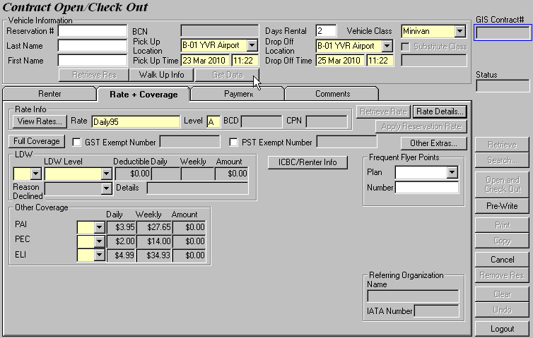
Figure 15: Click Get Data to automatically retrieve the rack rate in the Contract Open/Check Out screen.

Let’s assign another rate (e.g. Weekly95LM) to the Full Size 4Door in the scenario above using the same valid dates. You will be able to see the list of available rates for the Full Size 4Door in the Contract Open/Check Out screen by clicking on View Rates on the Rate + Coverage sub screen, as shown in Figure 16.

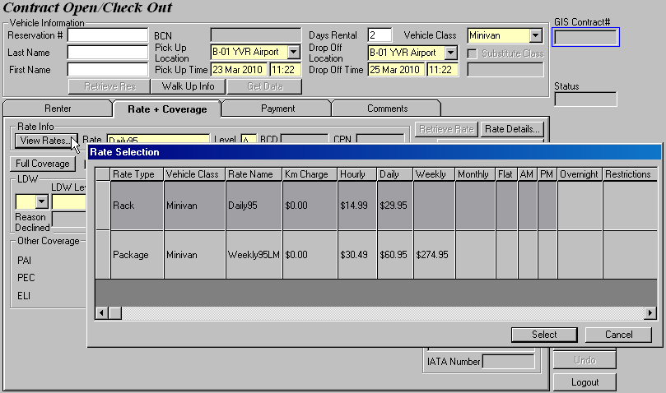
Figure 16: The View Rates button displays all available rates assigned to the selected vehicle class and pick up/drop off dates.

Now that you understand the basics of assigning rates to vehicle classes, go ahead and assign different rates to different vehicle classes. We also encourage you to play around with the promotional and package rates using different time periods to get a better understanding of the rate system in GIS.

3 Setting up a Package Rate

Defining a Rate

The way you set up a package rate is pretty much the same as how you set up your base rate. You might however, want to select ‘Promotional’ in the Purpose field of the Vehicle Rate Maintenance screen.

We will create a $99 three-day package that is offered across all locations for the sake of this tutorial. It is extremely important that you fully understand the concept of time periods so that you can manipulate the time periods and their corresponding rates to maximize your profits.

Specifying Rate Levels and Amounts

There are countless ways to define your rate amounts. Consider two rate settings for our three-day package (See Figure 17) and a possible rental scenario in each case.

Rate Strategy 1: Distribute $99 evenly across three days

This is a perfectly acceptable setting for your package. However, if a customer is offered this 3-day package during contract open but returns the car after just one day, the rental you can collect is only $33.

Rate Strategy 2: Allocate most of the rental on the first day and charge 1 cent for the two subsequent days so that the total equals $99 for three days

This is a better setting from the business point of view since majority of the rental is placed on the first day and customers usually keeps the car for the first day. If a customer is offered this 3-day package but returns the car after one day, your profit for that day is $98.97 as compared to $33 in the previous case.

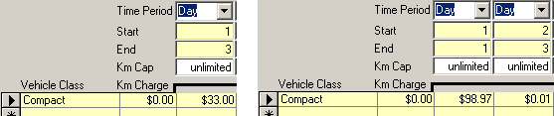
Figure 17: (Left) Case 1 with equal distribution; (Right) Case 2 with a better rate setting to prevent loss.

In our rate strategies, we only covered the rate amounts for three days but recall that a time period of Day must always start with 1 and end with 9999. Furthermore, a customer who rented a car from you using the 3-day package rate may decide to extend the rental if s/he needs it longer, or return the car slightly later than the expected drop off time due to a traffic jam.

With all these factors in mind, you should adjust the time period settings so that the most important first three days are set correctly and take into account any additional days or even additional hours. See Figure 18 for an example of a good three-day package. Notice that the time period of Hour starts from 73 because this is an additional setting on top of the 3-day package and we only want the hourly rate to kick in after the third day (i.e. 72 hours).

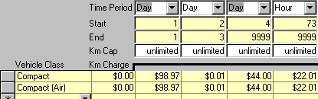
Figure 18: A complete three-day package rate for Compact cars.

Adding Restrictions to the Rate

Switch to the Restrictions tab. Here, you can apply restrictions to the rate and specify a second rate to be used when the restrictions have been violated.

The restrictions in GIS are predetermined and are automatically enforced when selected. See the Number of Hours, Number of Days and Time of Day columns beside the Restrictions column? Some restrictions are associated with conditions and will only kick in when the condition is met.

NOTE
As of this writing, GIS does not allow you to enter restrictions manually. If you think that there is a restriction that has to be added, contact Budget Rent-a-Car of B.C. Ltd and we will add it to the predetermined list for you.

Recall that our rate is a three day package rate, which means it should only be offered to customers who rent our vehicles for at least three days. Click the first yellow row in the Restrictions grid and an arrow will appear to the right. Click on the arrow to choose from a list of predetermined restrictions. The one that matches our requirement is “day minimum rental” since we want the car to be kept for at least a week. So set the Number of Days to 3 and save your changes.

To keep our three-day package rate simple, we will not apply a violation rate to our rate. We will, however, cover violation rates in the next chapter so stay tune.

Assigning Pick Up and Drop Off Locations

In the previous chapter, we talked about how to create a group for your pick up locations and authorize drop off locations for your rate. Since this three-day package is offered in all locations, click New Group and the right double arrow button to move all the locations into the Selected Pick Up Locations in Group column. At the bottom left of the screen, check the Allow All Authorized Drop Off Locations box.

Save all your changes and you have successfully created a package rate.
Assigning Rates for Reservation and Walk Up

The last part is assigning the three-day package rate to the applicable vehicle classes in Location Maintenance. Since this rate is offered in all locations, you have to retrieve each location in Location Maintenance and manually apply the rate to the applicable vehicles in each location.

Save your changes and you can now assign the three-day package rate as you create a reservation or open a contract.

4 Setting up a Truck Rate

Things will get a little different here since truck rental rates work slightly different from cars. We normally rent out trucks by specific time blocks, namely the morning block (AM), afternoon block (PM) and overnight block (OV). The hours for these blocks are 7.30am – 12.30pm; 12.30pm – 5.30pm; 5.30pm – 7.30am respectively and are preset in the GIS database.

Since trucks are rented by time blocks, there are six basic combinations as you establish your truck rates.

AM block – Renting a truck in the morning only

PM block – Renting a truck in the afternoon only

OV block – Renting a truck in the evening/at night only

AMPM block – Truck rental spans two continuous blocks starting in the morning

PMOV block - Truck rental spans two continuous blocks starting in the afternoon

OVAM block - Truck rental spans two continuous blocks starting in the evening

In this tutorial, we will touch upon both the individual and the continuous time blocks. Once you get the hang of time blocks, combined with your knowledge of regular time periods and kilometer cap, you are on your way to becoming a rate pro!

Defining a Rate

Start off by creating a very basic truck rate called AM109.99 for morning rentals. This rate is targeted to movers and we will include a dolly along with this rate for free. Next, populate the Purpose and Valid Dates fields. Keep in mind that this truck can only be picked up from downtown but can be returned to any location. Move on to the Rate Amount tab.

Specifying Rate Levels and Amounts

As usual, click New Level to enable the screen. Since our truck rental is only valid for morning rentals, select ‘AM’ in the Time Period field. GIS sets the Start and End fields to 1 and disables them to represent one time block with a preset time from 7.30am – 12.30pm. Leave the Km Cap at 0 so that customers are charged for extra mileage. The last step here would be to enter the vehicle classes associated with the rate and their respective Km charges and block rates. But what happens if the truck is returned late?

Customers are typically penalized with a daily rate they return their trucks after the end of their allowable time block. So add a column for the time period of Day to our AM109.99 rate, as shown in Figure 19.

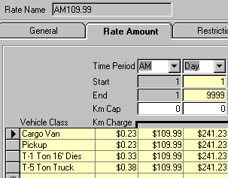
Figure 19: A morning block rate for trucks.

Adding Inclusions to the Rate

Let’s move to the Inclusions tab. This tab allows for the selection of Optional Extras (including LDW and third party insurance), Sales Accessories, and Taxes to be included in the rate at no additional charge.

Take a look at the Included Optional Extras section first. Click on the first yellow row and a list of available optional extras appears. After you select ‘Dolly’ from the list, enter an Included Daily and a Quantity.

Included Daily is the cost of your optional extra, which accounts for much less when compared with the actual sales price (i.e. Current Daily). Notice that there is a number beside each optional extra which signifies the maximum quantity allowable. Therefore, when you specify the Quantity for your optional extra, you cannot enter a value that exceeds the maximum quantity. Here we will select one dolly and enter its base cost, as shown in Figure 20.

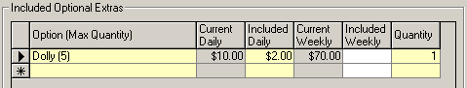
Figure 20: Including one dolly in the special truck rental rate.

Our AM109.99 does not include any optional extras, so now we shall move on to the Included Sales Accessories section.

In the sales accessory list, the accessory is displayed along with its unit description, which defines in what unit the sales accessory is sold. Like optional extras, you have to enter an Included Price and a Quantity as you select a sales accessory. However, there are no maximum quantities for sales accessories. Our AM109.99 does not include sales accessories as well, so let’s go to the Included Taxes and Fees section.
Our truck rate is merely a net rate so it does not include any special fees and taxes.

NOTE
The inclusion of taxes and specific fees is normally found in government and tour rates.

Save your changes in this screen and continue to the Locations tab.

Assigning Pick Up and Drop Off Locations

In the Locations sub screen, create a new group and put B-03 Downtown in it. Next, select the Allow All Authorized Drop Off Locations check box. Now your rate will be eligible for use when the customer picks up a truck in the downtown location.

Assigning Rates for Walk Up

After specifying the drop off and pick up locations where the rate is applicable for, the final step is to determine which vehicle classes can be used for the rate during reservation and contract open.

Open up the Location Maintenance screen and enter ‘B-03 Downtown’ in the Location field then hit Retrieve. With all the airport information loaded, go to the Vehicle Class Rate tab and select the All (Date set) sub tab.

On the right hand corner of the screen, select the Walk Up scenario to customize the rate offered in the Contract Open/Check Out screen. The For Use From field defaults to the current date. Select a Vehicle Class (e.g. Cargo Van) and click Retrieve. In the Rate by Vehicle Class grid will be enabled, choose ‘Package’ in the Selection Type column and enter AM109.99 and A in the Rate Name and Rate Level fields. Save your changes. As you open a contract for a Cargo Van, the AM rate will apply if the pick up and drop of time are within the AM time block (i.e. 7.30am – 12.30pm). If the rental falls outside of the AM time block or if it is extended from the original morning rental, the daily rate of AM109.99 will kick in.

NOTE
We only focus on the Walk Up scenario in this tutorial. The procedures in our tutorial will apply to all other scenarios, including Reservation.

Let’s look at another example for a continuous time block rate – AMPM block. Let’s add some spice into this rate by restricting customers to return the truck on time and penalizing them with a more expensive rate if they don’t’.

Defining a Rate

In Vehicle rate Maintenance, create a new rate called AMPM84.99 and set its Purpose and Valid Dates as before.

NOTE
A good naming convention for truck rates is a combination of the time block(s) involved and the amount per time block.

Specifying Rate Levels and Amounts

The Time Period fields should be none other than AM and PM. Set the Km Cap field to 0 again because the rate does not come with free mileage. Now how should we set the rate amount? The rate for each time block in this tutorial is $84.99. So logically, we would set the AM and PM rate amount to $84.99 each so that the entire AMPM package amounts to $169.98, as shown in Figure 21.

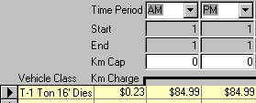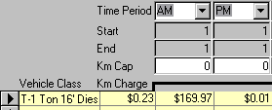
Figure 21: Distributing rate equally across blocks. Figure 22: Allocating a heavier weight in first block.

You should always protect yourself from any loss of profit as you set up rate. And distributing an equal rate across your time periods generally leads to losses. A customer who is offered this AMPM84.99 rate may return the vehicle earlier in the morning when he is expected to keep the vehicle until the afternoon. So instead of making a profit of the package, we only receive half the profit.

Therefore, a safer method to go about solving this problem is to allocate most of the rate amount in the first time block so that we won’t be affected by the customer’s early or late return (See Figure 22).

Adding Restrictions to the Rate

Here’s where things get interesting. Let’s switch to the Restrictions tab. Recall earlier in the chapter that the customer has to return the vehicle on time or s/he would be charged for more.

Click the first yellow row in the Restrictions grid and an arrow will appear to the right. Choose ‘Must be returned by drop off time on contract’ from the list since it matches our requirement.
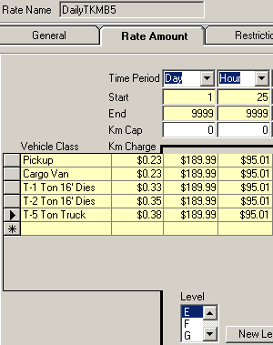
To penalize any late returns, we will create a violation rate. The Restriction Violation Rate Name (See Figure 23) is the rate that will automatically be used if any of the selected restrictions are violated. You can manually enter the rate name and level, or use the Rate Search function to look for a rate.

We will use a truck rate created specifically for this tutorial called DailyTKMB5 (See Figure 24) in the Restriction Violation Rate Name field and E in Level.
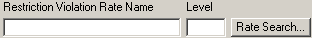
Figure 23: Adding a violation rate to SimpleTourRate.

Figure 24: Rate details of DailyTKMB5.

NOTE
It is not always the case that you need to add a violation rate after selecting a restriction.

Assigning Pick Up and Drop Off Locations

In the Locations sub screen, create a new group and put B-01 YVR Airport in it. Next, select the Allow All Authorized Drop Off Locations check box. Now your rate will be eligible for use when the customer checks out a T-1 Ton 16’ Diesel from the airport location.

Assigning Rates for Walk Up

Retrieve the T-1 Ton 16’ Diesel in Location Maintenance for B-01 YVR Airport. Attach AMPM84.99 Level A to the rate as a ‘Package’ rate and save your changes.

If you are interested in seeing the violation rate in action, we’ll be happy to guide you through. When the customer returns with the vehicle, retrieve his contract on GIS in the Contract Check In screen and you will see that GIS has already registered the early return of the vehicle and automatically applied the violation rate (See Figure 25). The violation rate is applied to the entire rental period.

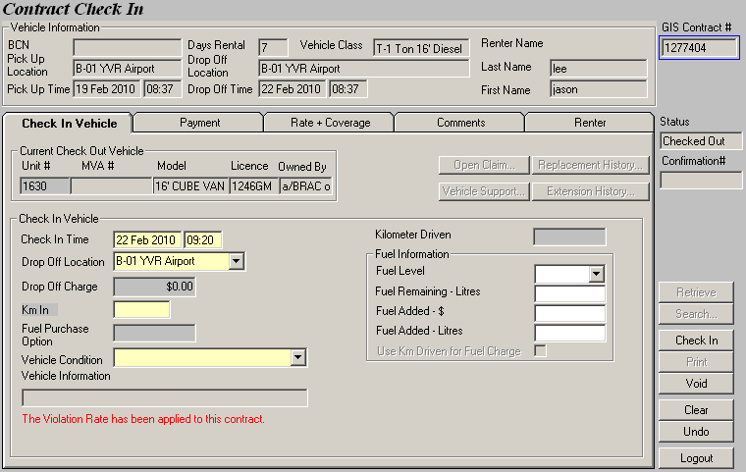
Figure 25: GIS alerts you when it applies the violation rate if the minimum 7-day rental is not met.

Switch to the Rate + Coverage tab. Notice that the current Selected Rate shows the violation rate DailyTKMB5 Level E, as shown in Figure 26.

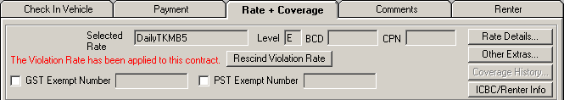
Figure 26: GIS shows the violation rate in effect.

NOTE
You should always make sure that your violation rate is valid during the entire time the specified rate (in this case, your truck rate) is valid.

Whew! That wraps up pretty much everything you need to know about truck rates. Good job on following us this far. Now relax yourself for a bit before we take on tour rates.

5 Setting up a Tour Rate

Defining a Rate

Our tour rate is designed specifically for a tour agency that offers a combination of accommodation and transportation in one package. This rate will only be available by reservation for any vehicle rental at any location for at least a week. Best of all, it is inclusive of all taxes/fees and includes an additional driver for no extra charge.

Access the Vehicle Rate Maintenance screen by selecting it from the Rate Control menu. Name our rate SimpleTourRate, effective from Mar 3, 2010 and select Tour Pkg as its purpose. Instead of printing the actual rates on the contract, we will mark up the rate to lead the customers to think that they receive a very good deal from the tour package. Let’s mark up the rate by 25%, through the Amount Markup field. Leave all the flags unchecked since none of them apply to our rate.

NOTE
When you want to set up a tour rate, select Tour Pkg (instead of Tour) from the rate Purpose field and enter an Amount Markup (This field is in percentage).

The amount you can markup is typically one of these three selections – 10%, 15% and 25%, depending on the contract between you and the tour agencies.

There are times when you allow your customer to add an additional driver free of charge. We would like to give our customers this option using this rate, but there is no flag specifying an additional driver! We’ll come back to this problem later, but make a note about this in the Comments section. Add two comments about including all taxes in this rate (which we will cover when we talk about the Inclusions tab) and about excluding fuel charges. Take a look at Figure 27 to check our progress so far.

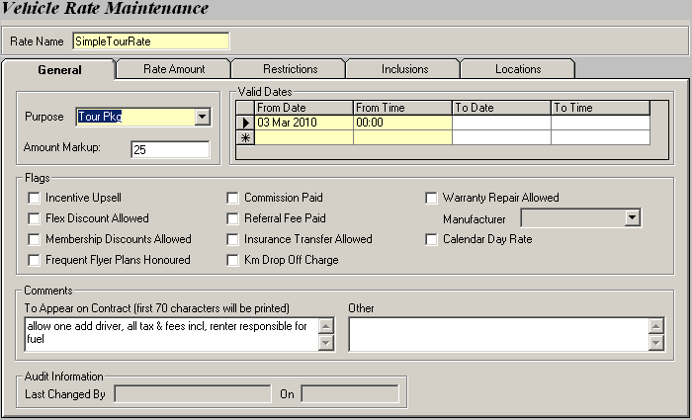
Figure 27: Entering basic information for our SimpleTourRate.

Specifying Rate Levels and Amounts

Let’s move to the Rate Amount tab to define the rate in details. Click the New Level button to enable the screen will be enabled. Next, define the Time Period such that the first 7 days will follow a special rate and any additional days and hours after the first week are charged differently. Enter 200 in Km Cap. Lastly, assign rate amounts and Km charges to the following vehicle classes: Compact, Intermediate (Air), Full Size 4Door, Luxury and Minivan. Save your work.

Adding Restrictions to the Rate

Switch to the Restrictions sub screen. Recall that our rate will only be in effect if the customer’s rents a vehicle for at least a week. Select ‘day minimum rental’ since we want the car to be kept for at least a week and set the Number of Days to 7. Save your changes.

Adding Inclusions to the Rate

At the start of our tutorial, we stated that SimpleTourRate is inclusive of all taxes and fees. So go ahead and tick all but the Fuel Purchase Option box (See Figure 28).

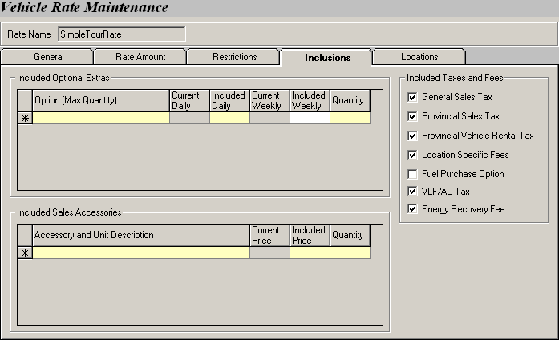
Figure 28: Include all taxes and fees, except for the Fuel Purchase Option in SimpleTourRate.

Assigning Pick Up and Drop Off Locations

Create a new group and shift all the locations right into the Selected Pick Up Locations in Group column. Select the Allow All Authorized Drop Off Locations check box so that the rate is applicable at all locations.
Assigning Rates for Reservation

By now you should be very familiar with assigning rates to a vehicle class. Open up the Location Maintenance screen and enter ‘B-01 YVR Airport’ in the Location field then hit Retrieve. With all the airport information loaded, go to the Vehicle Class Rate tab and select the All (Date set) sub tab.

On the right hand corner of the screen, select the Reservation Same Day scenario since we are customizing the rate offered in the Reservations screen. Attach SimpleTourRate as a ‘Promotion’ rate to Compact, Intermediate (Air), Full Size 4Door, Luxury and Minivan.

Do the same for all the other locations and the SimpleTourRate is ready to be used at any location in the Reservations screen.

This concludes our tutorial for setting up a rate. Next we shall walk you through the Organizations module and link it to the rate we created in this tutorial.

6 Setting up an Organization

Associating a Rate with an Organization

Bring up the Organization screen by selecting it from the Customer menu. Start by giving your organization a Name and a BCD Number. Populate the Organization Info and Contact Info sections. Finally, in the Corporate Rate grid, we need to search for a rate and link it to the organization. Click Rate Search to bring up the Rate Search window, as shown in Figure 29. You can search for your rate via several parameters, such as Rate Name, Purpose, Valid dates etc. Here we will search for our SimpleTourRate by name. Note that you can enter the first few letters of the rate (e.g. Enter the first three letters – sim) you are searching for and click Retrieve. GIS will display a list of rates which begin with ‘sim’ on the lower portion of the screen. If only one rate matches your search query, GIS will automatically return the result to the Corporate Rate grid that called the search. After the rate is retrieved, enter the Valid From/To date and time fields.

NOTE
Companies may have multiple rates assigned to them.

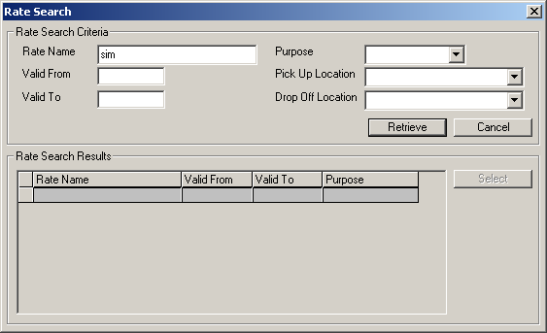
Figure 29: Rate Search allows a search based on multiple search parameters.

This Organization screen also displays the minimum age requirements by vehicle class and allows you to specify Minimum Age Overrides (exceptions) for the organization. The minimum age requirements for most vehicle classes in GIS are 21 and 25. Set it to 18 for all the Compact, Intermediate (Air), Full Size 4Door, Luxury and Minivan vehicle classes associated with SimpleTourRate, as shown in Figure 30. Save your changes.

Now, switch to the Referrals tab. This tab allows you to view or edit information on organizations that will receive a commission when they refer a customer to Budget. In the Payable To section, you can define whether commissions are payable to either the organization or an employee of the organization. Keep in mind that commissions are valid for only a limited time period and are either a fixed amount or a percentage of the rental only revenue (excludes items such as LDW).

The Maestro Reservations section allows you to define whether or not you will pay the organization a commission, or honor the customer’s frequent flyer plan when a customer uses its BCD number to make a reservation online.

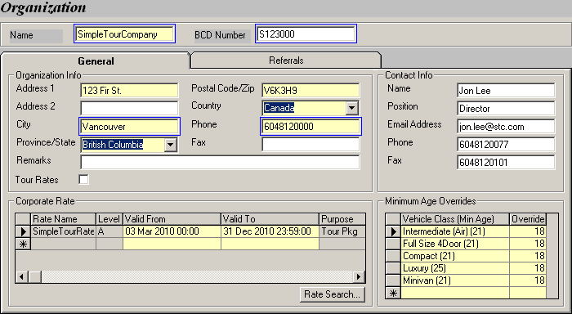
Figure 30: Creating an organization and linking a rate to it.

Leave the Referrals screen as is and we are now finished with the Organization tutorial. The last part of the tutorial will show you how an organization rate is pulled up when your staff makes a reservation or opens a contract.

Making a Reservation using a BCD number

Open the Reservations screen by selecting the Reservation menu. Recall that in order to use the SimpleTourRate, your minimum number of rental days is seven and you are limited to renting from one of the following vehicle classes - Compact, Intermediate (Air), Full Size 4Door, Luxury and Minivan.

With these two prerequisites in mind, go ahead and populate the Vehicle Information section at the top of the screen. Once you are finished, select the Rate tab and go to its Organization/Referral sub screen. In the Organization Information section, retrieve the organization’s information by entering the BCD number or the name of the organization (See Figure 31).

NOTE
Searching for an organization using the BCD number requires you to enter the full BCD number. On the other hand, you can do a speed search by typing in the first few letters of the organization’s name.

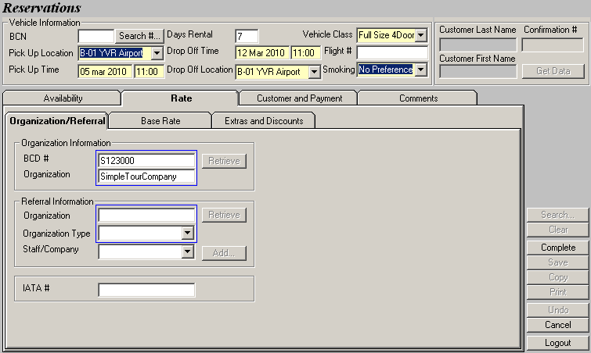
Figure 31: Making a reservation using a BCD number.

Now if you switch to the Base Rate sub tab, notice that the rate and rate level associated with the organization are already retrieved, which in our case is none other than SimpleTourRate Level A (See Figure 32). After the rate is loaded, you can complete the remaining portion of the reservation.

NOTE
When there is more than one rate assigned to an organization, GIS will load the first rate in the Corporate Rate grid of the Organization module into the reservation. The first rate listed in the grid may not necessarily be the first rate attached to the organization.

If you do not want to use the rate that GIS retrieved, you may select your own BCD rate by clicking on the View Rates button to bring up a list of all rates associated with the BCD number.

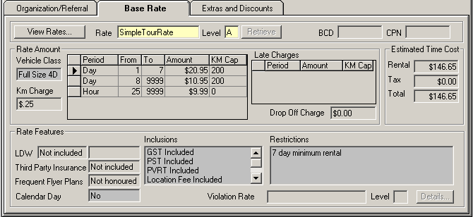
Figure 32: The associated organization rate is loaded into the reservation.
Opening a Contract using a BCD number

Before you start, you should realize that you will not be able to retrieve a walk up rate using the BCD number for Simple Tour Company because its corresponding rate – SimpleTourRate is not set up for walk up in Location Maintenance. Recall that we this rate was only set up for reservations. Go to Location Maintenance and assign the rate to a Full Size 4Door at the YVR Airport location. If you are unsure of how to do this, refer to Chapter 2. Once you are done, proceed to the next paragraph.

Opening a contract using a BCD number is more or less the same as making a reservation. Bring up the Contract Open/Check Out screen by selecting it from the Contract menu. Populate the Vehicle Information section at the top of the screen and click Walk Up Info. Once the Contract Affiliations window appears, select BCD as the Type of Walk Up Customer. Now you can retrieve your organization either by BCD number or by name (See Figure 33). Click Contract to close the window.

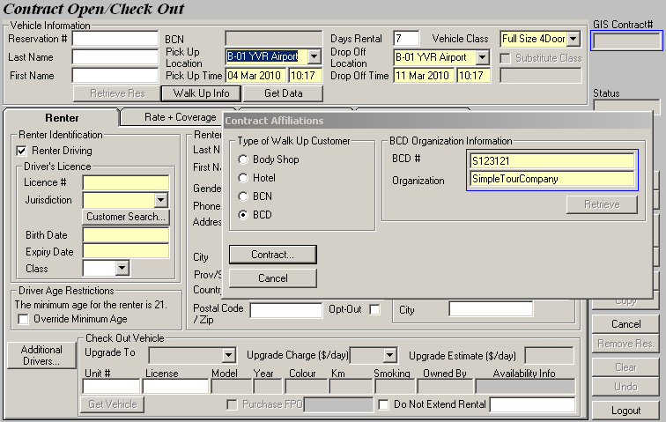
Figure 33: Entering BCD information in the Walk Up Info – Contract Affiliations window.

Switch to the Rate + Coverage tab and see that the associated rate and level are retrieved automatically. The BCD number is also displayed, as shown in Figure 34.

NOTE
If you do not want to use the rate that GIS retrieved, select another rate (if any) by clicking on View Rates to list all rates associated with the BCD number.

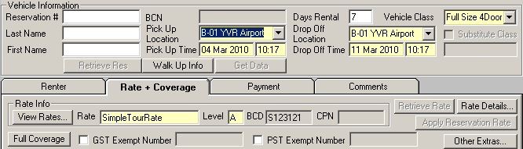
Figure 34: The associated BCD rate is loaded into the contract.

After the rate is loaded into the contract, you can complete the remaining portion of the contract and check out the vehicle.

We have reached the end of the rate control tutorial.

